# Article – 1: Integrating Machine Availability and Preventive Maintenance to Improve Productive Efficiency in a Manufacturing Industry

Abstract: T**he text discusses the issues of low productive efficiency and high machine downtime in manufacturing industries and highlights the importance of equipment maintenance for improving productive efficiency. It focuses on integrating preventive maintenance (PM) and machine availability to enhance productivity. A strategic process improvement plan using Lean Six Sigma (LSS) is presented, specifically employing the DMAIC (Define, Measure, Analyze, Improve, Control) approach.**

**A case study with around 600 employees is used to demonstrate the successful implementation of LSS. The study involves qualitative and quantitative analysis through structured questionnaires, surveys, and journals. Findings reveal that an average of 68% contribution leads to 79% productive efficiency. Efforts to decrease downtime and improve efficiency are based on a scheduled maintenance checklist plan supported by overall equipment effectiveness (OEE) benchmarks.**

**A linear regression model shows a significant relationship between machine availability and productive efficiency. The study proposes solutions using statistical analysis, focusing on sustainability and a measurement model based on DMAIC criteria. This resulted in a 20% improvement in machine availability, 44.3% in quality, 29.9% in productive efficiency, and 57.4% in OEE for the case study.**

**The research confirms LSS as a sustainable solution for reducing defects, maximizing efficiency, and optimizing resources in manufacturing industries. It emphasizes the methodology as a catalyst for positive change, improving machine performance and customer satisfaction.**

• **The study focuses on integrating machine availability and preventive maintenance to improve productive efficiency in a manufacturing industry.**

**• Lean Six Sigma (LSS) and the DMAIC (Define, Measure, Analyze, Improve, Control) methodology were used to implement process improvements.**

• **The research was conducted at a lubricant and chemical manufacturing industry in Nigeria.**

**• Data was collected over 12 months on an OCME Filling Machine (HYDRA 100 80 20).**

**• Key metrics analyzed included Mean Time Between Failures (MTBF), Mean Time To Repair (MTTR), Machine Availability (MA), Productive Efficiency (PE), Quality, and Overall Equipment Effectiveness (OEE).**

**• A linear regression analysis showed a significant positive correlation between machine availability and productive efficiency.**

• **After implementing LSS and a new preventive maintenance schedule:**

Machine Availability is given as

**Machine Availability = Actual Running time / Total Operating time x 100**

**MTBF = Total No of Operating Time / No of failures**

**MTTR = Total Operating Time / No of Repairs**

**- MTBF increased from 182.3 hours to 403 hours on average**

**- MTTR decreased from 56.3 hours to 20 hours on average**

**- Machine Availability improved by 20%**

**Quality = 𝐺𝑜𝑜𝑑𝐶𝑜𝑢𝑛𝑡 / 𝑇𝑜𝑡𝑎𝑙𝐶𝑜𝑢𝑛t**

**- Quality improved by 44.3%**

**Maximum Possible Output = Maximum Speed per batch x No. of working days**

**Actual output = N𝑜 𝑜𝑓 𝑏𝑜𝑡𝑡𝑙𝑒𝑠 𝑓𝑖𝑙𝑙𝑒𝑑 𝑥 𝑁𝑜 𝑜𝑓 𝑤𝑜𝑟𝑘𝑖𝑛𝑔 𝑑𝑎𝑦𝑠 – 𝑇𝑖𝑚𝑒𝑙𝑜𝑠t**

**Productive Efficiency = Actual Output / Max possible Output x 100**

**- Productive Efficiency increased by 29.9%**

**OEE = Availability × performance rate × quality × 100%**

**- OEE improved by 57.4%, reaching 80.2% (close to the world-class standard of 85%)**

• **The study concluded that Lean Six Sigma is an effective methodology for reducing defects, minimizing downtime, and improving overall productive efficiency in manufacturing industries.**

**• The research emphasizes the importance of continuous improvement and resource optimization in manufacturing processes.**

### Key Points

* **Problem:** **The manufacturing industry faces challenges of low productive efficiency and frequent machine breakdowns.**
* **Solution:** **Lean Six Sigma (LSS) methodology, specifically the DMAIC approach, is applied to identify and address the root causes of downtime.**
* **Implementation:** **A comprehensive preventive maintenance plan is developed and implemented based on the DMAIC approach, focusing on key areas like unscheduled maintenance, operator error, and tooling changeover**.
* **Key Performance Indicators:** **Machine availability, productive efficiency, quality, and overall equipment effectiveness (OEE) are measured and monitored throughout the process.**
* **Results:** **The implementation of the LSS approach resulted in significant improvements, including a 20% increase in machine availability, 44.3% improvement in quality, 29.9% increase in productive efficiency, and a 57.4% increase in OEE.**
* **Benefits:** **Reduced downtime, increased customer satisfaction, lower production costs, and improved profitability are realized through the implemented improvements.**
* **Methodology:** **A combination of quantitative and qualitative data analysis, including surveys, interviews, and statistical analysis, is used to evaluate the effectiveness of the implemented solutions.**
* **Key Findings:** **The research affirms the effectiveness of the Lean Six Sigma DMAIC approach as a sustainable solution for improving machine performance and overall productive efficiency in manufacturing industries.**

**The effectiveness of the Lean Six Sigma DMAIC approach can be further optimized for different types of manufacturing industries by considering the following:**

**By carefully considering these challenges and considerations, resource-constrained manufacturing environments can successfully implement the LSS DMAIC approach to achieve significant improvements in efficiency, quality, and profitability.**

**Integrating the LSS DMAIC approach with Total Productive Maintenance (TPM) can create a powerful synergy for achieving even greater efficiencies in manufacturing environments. Here's how:**

Data related to our dataset

* 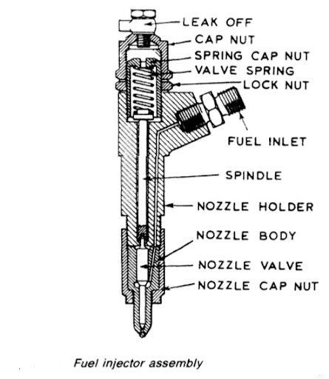**A spring-loaded spindle is used to keep the nozzle valve pressed against its seat in the nozzle body. As the fuel is supplied by fuel injection pump with sufficient pressure to lift the nozzle valve against the spring force, then a spray of atomized fuel is fed into the combustion chamber**.
* **The mechanical part of the oil pump consists of a submersible pump or a suction pump. The suction pump uses vacuum pressure to draw oil and deliver it to the vehicle.**

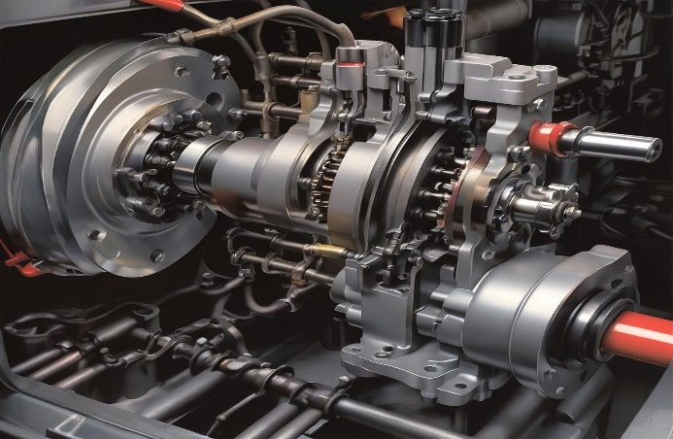

**Key Points:**

1. **Role of the Spindle:**
   * **The spindle is a crucial component in the fuel pump, responsible for driving the rotor and ensuring efficient fuel delivery.**
   * **It converts rotational motion into the necessary mechanical energy to pump fuel.**
2. **Normal Operating Speed:**
   * **The typical normal operating speed for a spindle in a fuel pump is between 2000 to 4000 RPM.**
   * **Operating within this speed range ensures optimal fuel delivery and system performance.**
3. **Importance of Maintaining Normal Levels:**
   * **Ensuring the spindle operates at the correct speed prevents excessive wear and tear.**
   * **Proper alignment and lubrication are vital for reducing friction and heat, extending the lifespan of the spindle and the entire pump.**
4. **Consequences of Abnormal Conditions:**
   * **Low Speed (<2000 RPM): May result in inadequate fuel delivery, leading to engine performance issues or stalling.**
   * **High Speed (>4000 RPM): Can cause excessive wear, overheating, and potential failure of the spindle and associated components.**
5. **Monitoring and Maintenance:**
   * **Regularly check the spindle speed using a tachometer or similar device.**
   * **Inspect the spindle for signs of wear, misalignment, or inadequate lubrication.**
   * **Ensure the spindle and associated components are properly lubricated and free from debris.**
6. **Adjustments and Repairs:**
   * **If the spindle speed is consistently outside the normal range, investigate and resolve underlying issues such as misalignment or lubrication problems.**
   * **Routine maintenance and timely repairs can prevent costly breakdowns and extend the life of the fuel pump.**

### **What is the purpose of hydraulic pressure?**

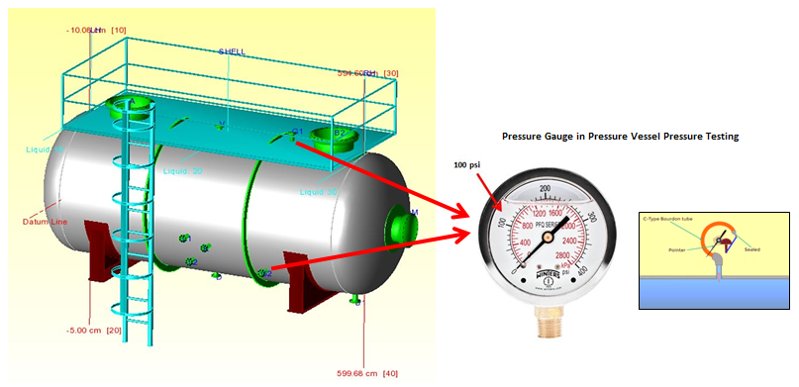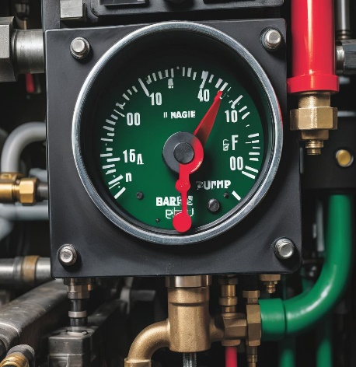

* **Hydraulic pressure is the amount of force applied to a liquid or gas by a pump. It is measured in pounds per square inch (PSI). Normal hydraulic pressure is between 3000 and 4000 psi. Hydraulic pressure is used in a variety of applications, such as irrigation, mining, oil drilling, and manufacturing.**
* **Beyond its most rudimentary role of providing fluid storage, the main functions of the hydraulic tank are to dissipate heat and allow contaminants to settle out of the fluid.**
* **Normal hydraulic pressure is between 3000 and 4000 psi**
* **The accepted international standard for maximum working pressure in the high-pressure hydraulic tools industry is 700 Bar (10,000 PSI). The criteria for establishing the maximum output force of a hydraulic cylinder at 700 Bar pressure is the size of the effective area of the cylinder bore.**

**Key Points:**

1. **Normal Pressure Range:**
   * **The typical normal hydraulic pressure for a fuel pump system is between 150 to 300 bar.**
   * **Operating within this range ensures optimal performance and longevity of the fuel** pump.
2. **Importance of Maintaining Normal Pressure:**
   * **Maintaining the hydraulic pressure within the normal range ensures efficient fuel delivery and system stability.**
   * **It prevents damage to the fuel pump and other components due to pressure fluctuations.**
3. **Consequences of Abnormal Pressure:**
   * **Low Pressure (<150 bar):** **May result in inadequate fuel delivery, causing engine performance issues or stalling**.
   * **High Pressure (>300 bar):** **Can lead to excessive stress on the pump and hydraulic lines, potentially causing leaks or system failures.**
4. **Monitoring and Maintenance:**
   * **Regularly check the hydraulic pressure using a reliable gauge.**
   * **Inspect the hydraulic system for leaks, blockages, or other issues that could affect pressure levels.**
   * **Ensure the hydraulic fluid is at the correct level and the system is free from air pockets.**
5. **Adjustments and Repairs:**
   * **If the pressure is consistently outside the normal range, investigate and resolve underlying issues.**
   * **Routine maintenance and timely repairs can prevent costly breakdowns and extend the life of the fuel pump.**

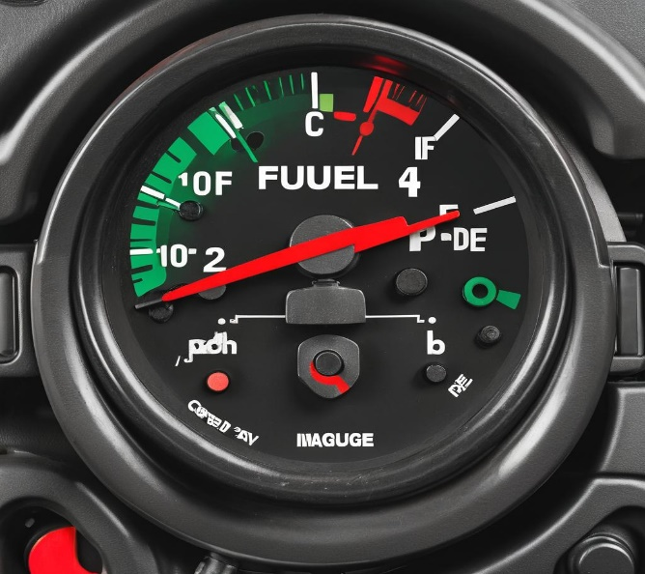

### **Coolant Pressure Bar: Normal Level for Fuel Pump Manufacturers**

Key Points:

1. **Normal Pressure Range:**
   * **The typical normal coolant pressure for a fuel pump system is between 1.0 to 1.5 bar.**
   * **Operating within this range ensures optimal performance and longevity of the fuel pump.**
2. **Importance of Maintaining Normal Pressure:**
   * **Maintaining the coolant pressure within the normal range prevents overheating.**
   * **It ensures the fuel pump operates efficiently without undue stress or wear.**
3. **Consequences of Abnormal Pressure:**
   * **Low Pressure (<1.0 bar):** **May lead to inadequate cooling, causing overheating and potential damage to the pump.**
   * **High Pressure (>1.5 bar):** **Can indicate blockages or faults in the cooling system, potentially leading to leaks or burst hoses.**
4. **Monitoring and Maintenance:**
   * **Regularly check the coolant pressure using a reliable gauge.**
   * **Inspect the cooling system for leaks, blockages, or other issues that could affect pressure levels.**
   * **Ensure the coolant is topped up and the cooling system is free from air pockets.**
5. **Adjustments and Repairs:**
   * **If the pressure is consistently outside the normal range, investigate and resolve underlying issues.**
   * **Routine maintenance and timely repairs can prevent costly breakdowns and extend the life of the fuel pump.**

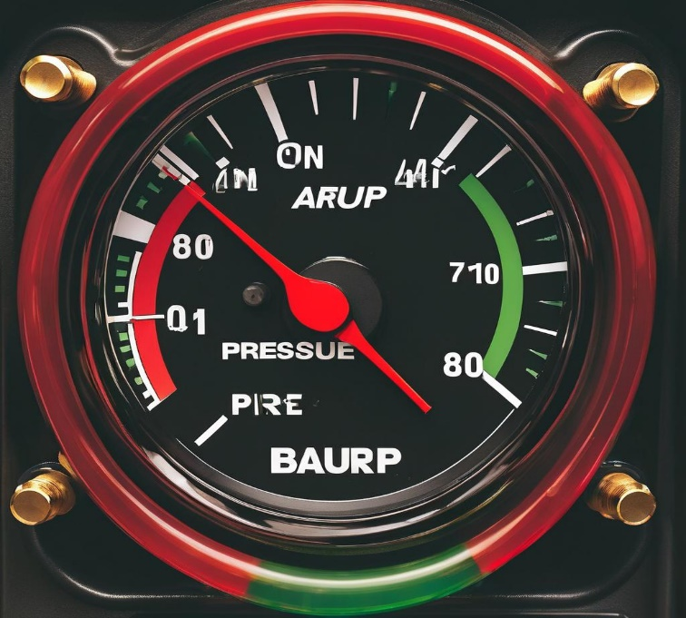

### **Air System Pressure Bar: Normal Level for Fuel Pump Manufacturers**

**Key Points:**

1. **Normal Pressure Range:**
   * **The typical normal air pressure for a fuel pump system is between 6 to 8 bar.**
   * **Operating within this range ensures optimal performance and efficiency of the fuel pump.**
2. **Importance of Maintaining Normal Pressure:**
   * **Maintaining air pressure within the normal range ensures consistent and efficient fuel atomization.**
   * **It prevents damage to the fuel pump and ensures stable operation of the system.**
3. **Consequences of Abnormal Pressure:**
   * **Low Pressure (<6 bar):** **May result in poor fuel atomization, leading to incomplete combustion and reduced engine performance**.
   * **High Pressure (>8 bar):** **Can cause excessive stress on the pump and air lines, potentially leading to leaks or system failures.**
4. **Monitoring and Maintenance:**
   * **Regularly check the air pressure using a reliable gauge.**
   * **Inspect the air system for leaks, blockages, or other issues that could affect pressure levels.**
   * **Ensure the air filters are clean and the air lines are free from obstructions.**
5. **Adjustments and Repairs:**
   * **If the pressure is consistently outside the normal range, investigate and resolve underlying issues such as leaks or blockages.**
   * **Routine maintenance and timely repairs can prevent costly breakdowns and extend the life of the fuel pump.**

### **Coolant Temperature: Normal Level for Fuel Pump Manufacturers**

**Key Points:**

1. **Normal Temperature Range:**
   * **The typical normal coolant temperature for a fuel pump system is between 85°C to 95°C.**
   * **Operating within this range ensures optimal performance and longevity of the fuel pump.**
2. **Importance of Maintaining Normal Temperature:**
   * **Maintaining coolant temperature within the normal range prevents overheating and reduces wear on the fuel pump components.**
   * **It ensures the fuel pump operates efficiently without undue stress or thermal degradation.**
3. **Consequences of Abnormal Temperature:**
   * **Low Temperature (<85°C):** **May result in inefficient fuel atomization and reduced engine performance.**
   * **High Temperature (>95°C):** **Can indicate overheating, leading to potential damage to the pump, seals, and other components.**
4. **Monitoring and Maintenance:**
   * **Regularly check the coolant temperature using a reliable gauge.**
   * **Inspect the cooling system for leaks, blockages, or other issues that could affect temperature levels.**
   * **Ensure the coolant is topped up and the system is free from air pockets.**
5. **Adjustments and Repairs:**
   * **If the temperature is consistently outside the normal range, investigate and resolve underlying issues such as blockages or leaks.**
   * **Routine maintenance and timely repairs can prevent costly breakdowns and extend the life of the fuel pump.**

### **Hydraulic Oil Temperature: Normal Level for Fuel Pump Manufacturers**

**Key Points:**

1. **Normal Temperature Range:**
   * **The typical normal hydraulic oil temperature for a fuel pump system is between 40°C to 60°C.**
   * **Operating within this range ensures optimal performance and longevity of the hydraulic system.**
2. **Importance of Maintaining Normal Temperature:**
   * **Maintaining hydraulic oil temperature within the normal range prevents overheating and thermal degradation of the oil.**
   * **It ensures the hydraulic system operates efficiently without causing excessive wear on the pump components**.
3. **Consequences of Abnormal Temperature:**
   * **Low Temperature (<40°C):** **May result in increased oil viscosity, leading to poor lubrication and inefficient pump operation**.
   * **High Temperature (>60°C):** **Can cause oil thinning, reducing its lubrication properties and potentially leading to component wear or failure.**
4. **Monitoring and Maintenance:**
   * **Regularly check the hydraulic oil temperature using a reliable gauge.**
   * **Inspect the hydraulic system for leaks, blockages, or other issues that could affect temperature levels.**
   * **Ensure the hydraulic oil is at the correct level and free from contaminants.**
5. **Adjustments and Repairs:**
   * **If the temperature is consistently outside the normal range, investigate and resolve underlying issues such as cooling system problems or excessive load.**
   * **Routine maintenance and timely repairs can prevent costly breakdowns and extend the life of the hydraulic system.**

### **Spindle Bearing Temperature: Normal Level for Fuel Pump Manufacturers**

**Key Points:**

1. **Normal Temperature Range:**
   * **The typical normal spindle bearing temperature for a fuel pump system is between 60°C to 80°C.**
   * **Operating within this range ensures optimal performance and longevity of the bearing.**
2. **Importance of Maintaining Normal Temperature:**
   * **Maintaining spindle bearing temperature within the normal range prevents overheating and reduces wear on the bearing components.**
   * **It ensures the fuel pump operates efficiently without causing excessive stress or thermal damage.**
3. **Consequences of Abnormal Temperature:**
   * **Low Temperature (<60°C):** **May result in increased bearing friction due to inadequate lubrication flow.**
   * **High Temperature (>80°C): Can cause lubrication breakdown, leading to increased wear and potential bearing failure**.
4. **Monitoring and Maintenance:**
   * **Regularly check the spindle bearing temperature using a reliable gauge.**
   * **Inspect the bearing for signs of wear, misalignment, or inadequate lubrication.**
   * **Ensure the bearing is properly lubricated and free from debris.**
5. **Adjustments and Repairs:**
   * **If the temperature is consistently outside the normal range, investigate and resolve underlying issues such as misalignment or lubrication problems.**
   * **Routine maintenance and timely repairs can prevent costly breakdowns and extend the life of the spindle bearing.**

### **Spindle Vibration: Normal Level for Fuel Pump Manufacturers**

**Key Points:**

1. **Normal Vibration Range:**
   * **The typical normal spindle vibration level for a fuel pump system is below 1.0 mm/s.**
   * **Operating within this range ensures optimal performance and longevity of the spindle and associated components.**
2. **Importance of Maintaining Normal Vibration Levels:**
   * **Maintaining spindle vibration within the normal range prevents excessive wear and tear on the spindle and bearings.**
   * **It ensures the fuel pump operates smoothly and efficiently without causing undue stress on the components.**
3. **Consequences of Abnormal Vibration:**
   * **Low Vibration (<1.0 mm/s): Indicates smooth operation and well-balanced components.**
   * **High Vibration (>1.0 mm/s): Can indicate misalignment, imbalance, or bearing wear, leading to potential damage or failure of the spindle and other components**.
4. **Monitoring and Maintenance:**
   * **Regularly check the spindle vibration using a reliable vibration meter.**
   * **Inspect the spindle and bearings for signs of wear, misalignment, or imbalance.**
   * **Ensure the spindle is properly balanced and all components are securely fastened.**
5. **Adjustments and Repairs:**
   * **If the vibration levels are consistently outside the normal range, investigate and resolve underlying issues such as misalignment, imbalance, or bearing problems.**
   * **Routine maintenance and timely repairs can prevent costly breakdowns and extend the life of the spindle and bearings**

### **Tool Vibration: Normal Level for Fuel Pump Manufacturers**

**Key Points:**

1. **Normal Vibration Range:**
   * **The typical normal tool vibration level for a fuel pump manufacturing system is below 2.5 mm/s.**
   * **Operating within this range ensures optimal performance and longevity of the tools and equipment.**
2. **Importance of Maintaining Normal Vibration Levels:**
   * **Maintaining tool vibration within the normal range prevents excessive wear and tear on the tools and the machinery.**
   * **It ensures that the manufacturing process is smooth, precise, and efficient, reducing the risk of defects**.
3. **Consequences of Abnormal Vibration:**
   * **Low Vibration (<2.5 mm/s):** **Indicates smooth operation and well-maintained equipment.**
   * **High Vibration (>2.5 mm/s):** **Can indicate tool misalignment, imbalance, or wear, leading to potential damage or failure of the tools and equipment, and possible defects in the manufactured products**.
4. **Monitoring and Maintenance:**
   * **Regularly check the tool vibration using a reliable vibration meter.**
   * **Inspect the tools and machinery for signs of wear, misalignment, or imbalance.**
   * **Ensure the tools are properly balanced and all components are securely fastened.**
5. **Adjustments and Repairs:**
   * **If the vibration levels are consistently outside the normal range, investigate and resolve underlying issues such as misalignment, imbalance, or tool wear.**
   * **Routine maintenance and timely repairs can prevent costly breakdowns and extend the life of the tools and machinery.**

### **Spindle Speed: Normal Level for Fuel Pump Manufacturers**

**Key Points:**

1. **Normal Speed Range:**
   * **The typical normal spindle speed for a fuel pump system is between 500 to 3000 RPM.**
   * **Operating within this range ensures optimal performance and longevity of the spindle and associated components.**
2. **Importance of Maintaining Normal Speed Levels:**
   * **Maintaining spindle speed within the normal range prevents excessive wear and tear on the spindle and bearings.**
   * **It ensures the fuel pump operates efficiently and effectively without causing undue stress on the components.**
3. **Consequences of Abnormal Speed:**
   * **Low Speed (<500 RPM):** **May result in inefficient pump operation and poor fuel atomization.**
   * **High Speed (>3000 RPM):** **Can cause excessive wear, overheating, and potential failure of the spindle and other components**.
4. **Monitoring and Maintenance:**
   * **Regularly check the spindle speed using a reliable tachometer.**
   * **Inspect the spindle and bearings for signs of wear, misalignment, or imbalance.**
   * **Ensure the spindle is properly balanced and all components are securely fastened.**
5. **Adjustments and Repairs:**
   * **If the speed is consistently outside the normal range, investigate and resolve underlying issues such as misalignment, imbalance, or bearing problems.**
   * **Routine maintenance and timely repairs can prevent costly breakdowns and extend the life of the spindle and bearings.**

### **Voltage: Normal Level for Fuel Pump Manufacturers**

**Key Points:**

1. **Normal Voltage Range:**
   * **The typical normal voltage level for a fuel pump system is between 12 to 14 volts (for a 12V system commonly used in automotive applications).**
   * **Operating within this range ensures optimal performance and longevity of the fuel pump's electrical components.**
2. **Importance of Maintaining Normal Voltage Levels:**
   * **Maintaining voltage within the normal range prevents under-voltage and over-voltage conditions that can harm the fuel pump and its associated electronics.**
   * **It ensures the fuel pump operates efficiently and effectively without causing undue stress on the electrical components.**
3. **Consequences of Abnormal Voltage:**
   * **Low Voltage (<12V):** **May result in insufficient power supply to the fuel pump, leading to poor performance or failure to operate**.
   * **High Voltage (>14V): Can cause overheating, damage to the pump's electrical components, and reduced lifespan**.
4. **Monitoring and Maintenance:**
   * **Regularly check the voltage using a reliable voltmeter.**
   * **Inspect the electrical system for signs of wear, loose connections, or damaged wiring.**
   * **Ensure the battery and charging system are functioning correctly to maintain a stable voltage supply.**
5. **Adjustments and Repairs:**
   * **If the voltage is consistently outside the normal range, investigate and resolve underlying issues such as a failing alternator, battery problems, or poor connections.**
   * **Routine maintenance and timely repairs can prevent costly breakdowns and extend the life of the fuel pump and its electrical components.**

### **Torque: Normal Level for Fuel Pump Manufacturers**

**Key Points:**

1. **Normal Torque Range:**
   * **The typical normal torque level for a fuel pump system assembly is between 20 to 30 Nm for standard bolts and components.**
   * **Operating within this range ensures optimal performance and longevity of the fuel pump and its components.**
2. **Importance of Maintaining Normal Torque Levels:**
   * **Maintaining torque within the normal range prevents under-tightening and over-tightening, which can lead to component failure or damage.**
   * **It ensures the fuel pump operates efficiently and effectively without causing undue stress on the mechanical components.**
3. **Consequences of Abnormal Torque:**
   * **Low Torque (<20 Nm):** **May result in loose connections, leading to leaks, vibrations, or component disassembly.**
   * **High Torque (>30 Nm):** **Can cause threads to strip, bolts to break, or components to crack, reducing the lifespan and reliability of the fuel pump**.
4. **Monitoring and Maintenance:**
   * **Regularly check the torque levels during assembly and maintenance using a reliable torque wrench.**
   * **Inspect the components for signs of wear, misalignment, or damage.**
   * **Ensure all bolts and connections are tightened to the manufacturer’s specified torque levels.**
5. **Adjustments and Repairs:**
   * **If the torque levels are consistently outside the normal range, re-torque the bolts and components to the correct specifications.**
   * **Routine maintenance and timely adjustments can prevent costly breakdowns and extend the life of the fuel pump and its components**

### **Cutting of fuel pump**

**Key Points:**

1. **Normal Cutting Force Range:**
   * **The typical normal cutting force for a fuel pump system assembly is between 5 to 10 kN ( Kilonewtons )for standard cutting operations.**
   * **Operating within this range ensures clean cuts and maintains the integrity of the fuel pump components.**
2. **Importance of Maintaining Normal Cutting Force Levels:**
   * **Maintaining cutting force within the normal range prevents incomplete cuts or excessive stress on the cutting tools and components.**
   * **It ensures the fuel pump parts are accurately machined, promoting efficient assembly and operation**.
3. **Consequences of Abnormal Cutting Force:**
   * **Low Cutting Force (<5 kN):** **May result in incomplete cuts, burrs, or rough edges, leading to poor assembly quality and potential malfunction**.
   * **High Cutting Force (>10 kN):** **Can cause excessive tool wear, breakage, or deformation of components, reducing the lifespan and reliability of the fuel pump.**
4. **Monitoring and Maintenance:**
   * **Regularly check the cutting force levels during machining using appropriate measurement tools.**
   * **Inspect the cutting tools for signs of wear, dullness, or damage.**
   * **Ensure the cutting force is adjusted to the manufacturer’s specified levels to maintain precision and quality.**
5. **Adjustments and Repairs:**
   * **If the cutting force levels are consistently outside the normal range, adjust the machining parameters or replace the cutting tools as needed.**
   * **Routine maintenance and timely adjustments can prevent costly rework, tool damage, and extend the life of the fuel pump and its components.**

**By following these key points, you can ensure that the cutting process of the fuel pump system assembly remains efficient and reliable, ultimately contributing to the overall performance and longevity of the fuel pump.**

# Article – 2: Risk analysis of machine failure factors in engine assembly process at PT. automotive

Problem Statement

* **The production system is disrupted through device failures, main to unmet market demand and suboptimal organization profits.**
* **PT. Automotive, an automotive employer in Indonesia, experiences system troubles affecting its manufacturing method.**

Variables Used

* **Machine Availability (MA): Percentage of time the machine is to be had to be used.**
* **MTBF (Mean Time Between Failures): Average operational time between machine breakdowns.**
* **MTTR (Mean Time To Repair): Average time taken to restore a system and return it to operational reputation.**
* **Quality: Percentage of defect-unfastened merchandise produced via the device.**
* **OEE (Overall Equipment Effectiveness): Combined degree of availability, overall performance, and excellent.**
* **RPN (Risk Priority Number): A cost used in FMEA to quantify the chance related to capacity failure modes.**
* **Critical RPN Value: A threshold value (68.963) used to prioritize corrective actions.**

Key Insights

* **FMEA ( Failure Mode and Effect Analysis ) Method Application: Used to assess screw ups within the manufacturing method, figuring out the threat degree and precedence for machine screw ups.**
* **Highest RPN Value: The maximum RPN cost for device failure is 225, indicating a important failure mode because of the stylus pin now not functioning efficiently.**
* **Risk Management: Failures with RPN values more than the important RPN fee (68.963) are prioritized for fast corrective motion.**
* **Impact of Machine Failures: Machine disasters disrupt production, risking unmet market demand and reduced enterprise income.**
* **Proposed Improvements: Implementing corrective movements based totally on FMEA outcomes to avoid manufacturing procedure disasters and enhance basic efficiency.**
* **Production Efficiency Goals: Increase system availability, lessen MTTR, improve great, and beautify OEE to attain most useful manufacturing overall performance.**

# Article – 3: AI-Based PdM Platform in Deciding Failure of Automobile SCU Equipment

Problem Statement

* **High Maintenance Costs: Automated factories face good sized charges because of preservation of expensive equipment.**
* **Downtime Impact: Equipment failures lead to sizeable financial losses, necessitating actual-time fault prediction era.**
* **Shift from PM to PdM: There is a want to shift from conventional Preventive Maintenance (PM) to Predictive Maintenance (PdM) for more suitable productivity.**

Variables Used

# **Predictive Maintenance (PdM): Predicts alternative cycles based on equipment circumstance as opposed to scheduled periods.**

# **Real-Time Fault Prediction: Technology to predict equipment screw ups before they arise.**

# **Industrial Internet of Things (IIoT): Infrastructure permitting connectivity and facts alternate between system and structures.**

# **Virtual Voltage and Frequency Data: Simulated facts used to teach predictive fashions.**

# **Artificial Intelligence (AI) Models: Recurrent Neural Network (RNN), Long Short-Term Memory (LSTM), Gated Recurrent Unit (GRU) used for fault prediction.**

Key Insights

# **Development of Predictive Maintenance Platform: Utilized IIoT to create a actual-time prediction device for system state.**

# **Model Comparison: Compared RNN, LSTM, and GRU fashions for fault prediction; GRU achieved highest speed and accuracy with an R2-rating of zero.992.**

# **Enhanced Productivity: Implementation geared toward decreasing downtime and improving productiveness via proactive maintenance strategies.**

# Article – 4: Comparative Analysis of MFCC and Mel-Spectrogram Features in Pump Fault Detection Using Autoencoder

﻿Problem Statement

• **Pump Fault Detection: The research objectives to decorate the detection of pump faults to prevent costly downtimes in commercial operations by way of comparing the effectiveness of audio feature extraction techniques, Mel-Frequency Cepstral Coefficients (MFCC) and Mel-spectrograms, in autoencoder models.**

Variables Used

* **Audio Feature Extraction Techniques:**
* **Mel-Frequency Cepstral Coefficients (MFCC)**
* **Mel-spectrograms**
* **Autoencoder Model: A form of neural network used for unsupervised mastering of efficient codings.**
* **Dataset: Malfunctioning Industrial Machine Investigation and Inspection (MIMII) dataset.**
* **Performance Metrics: Evaluation metrics to examine the effectiveness of MFCC and Mel-spectrograms in detecting pump faults.**

Key Insights

* **Feature Extraction Techniques: Compared MFCC and Mel-spectrograms for their effectiveness in fault detection.**
* **Training and Evaluation: An autoencoder turned into skilled on normal pump sounds and examined on both ordinary and anomalous sounds.**
* **Performance Results: Mel-spectrograms outperformed MFCCs in numerous overall performance metrics for fault detection.**
* **Significance of Feature Selection: Highlighted the vital function of selecting appropriate capabilities in improving autoencoder-based totally pump fault detection.**
* **Impact on Predictive Maintenance: Findings make contributions to optimizing predictive maintenance techniques via enhancing fault detection accuracy.**

# Article – 5: Applying Sensor-Based Information Systems to Identify Unplanned Downtime in Mining Machinery Operation

Problem Statement

* **Unplanned Downtime in Mining: Unplanned downtime of modern-day mining equipment due to tough environmental situations hinders the efficiency of underground mining operations.**

Variables Used

* **Environmental Conditions: Natural factors affecting mining operations.**
* **Machine Parameters: Data gathered from mining equipment via sensors.**
* **Downtime: Periods while machines are not operational.**
* **SCADA System: Supervisory control and facts acquisition device for tracking machinery.**
* **ERP System: Integrated corporation useful resource making plans system for handling mining operations.**

Key Insights

* **Sensor-Based Information System: Developed a methodology the usage of sensors to constantly sign in mining system parameters.**
* **Automated Data Collection: Implemented an industrial automation system with SCADA for operator-independent data series.**
* **IT Tool for Cause Identification: Created an IT application inside an ERP machine to perceive the reasons of machine downtime.**
* **Objective Downtime Registration: The answer allows for objective recording of system downtimes.**
* **Knowledge Discovery: The system exhibits previously undisclosed facts, presenting insights for improving machinery utilization.**
* **Application Example: Demonstrated the device's software on a shearer loader, displaying great capacity for boosting machinery efficiency.**
* **Efficiency Improvement: The advanced gadget contributes to higher usage of equipment and normal improvement of the mining manufacturing manner.**

Top of Form

Bottom of Form